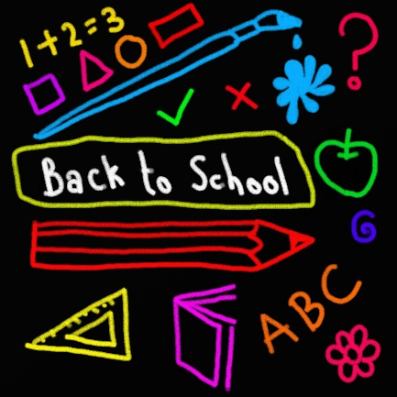
Back to school – new routines - primary

What is this?
Learning about routines and how this can help us all manage changes in our lives.

For children at nursery and P1
- There are many things that we all do every day. Talk with your child about the routines you and your family have as part of your daily lives. How many activities can they list as things that they do every day?
- Think back over the last few weeks. Ask your child if there are any new things that they now include in their daily routine? For example, hand washing, being active, and playing outside.
- Together, find a nursery rhyme or song that would help your child remember to wash their hands for 20 seconds.

