respectme Anti-bullying Training calendar
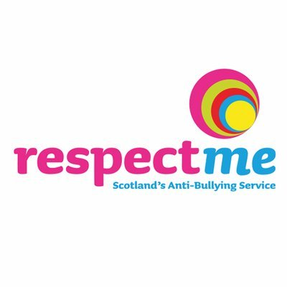

WEBINAR: Getting Ready for High School - Transitions and Positive Relationships: Wednesday, 22 July 2020, 6.30-7.30pm

WEBINAR: Online bullying and how to deal with it: Wednesday, 26 August 2020, 6.30-7.30pm

WEBINAR: Helping children to build resilience: Wednesday, 23 September 2020, 6.30-7.30pm

