Scottish Attainment Challenge

Mentoring Development Officers Activities

Activity Title: | Chalk Obstacle Course
Age range: | P7+
Area of the Curriculum: | Literacy and art
Resources required: | Chalk and a paved area
Time / length of the activity: | 1 hour
Number of people required: | 2+
Instructions:  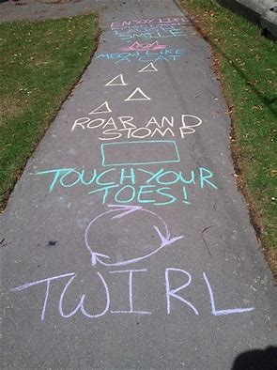  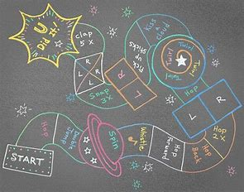 | - First find a clear paved area, this can be a driveway or a pathway.  - Take your chalk and begin to draw your own obstacle course.  - Begin with a box saying “start here”, then get creative.  - Add lines to follow, spaces to hop into, movements to make (like spin 3 times), touch your toes, whistle, make a noise like a cat and make sure you include all the instructions to follow.  - Time each other to see how quickly you can make it to the end.  - Design a chalk course for each other and see who can complete the quickest or go into teams and the first group to finish are the winners.
Further learning | Make your course more complicated and add in objects to use such as balance the ball on your toe or jump over a box 3 times.

For hygiene reasons please ensure you wash your hands and any objects you have been touching after you have finished the activity.

