Scottish Attainment Challenge

Mentoring Development Officers Activities

Activity Title: | Spiral
Age range: | P7+
Area of the Curriculum: | Numeracy
Resources required: | Two dice, counters, beads or small stones and pack of playing cards.
Time / length of the activity: | 45 minutes
Number of people required: | 2+
Instructions:  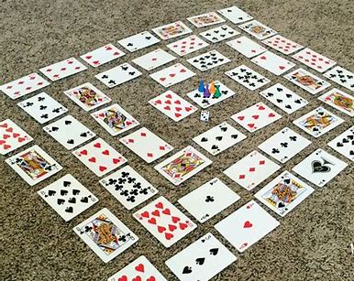 | - Start with a complete set of cards, and game pieces (stones, beads or counters) for each player.  - The Ace =1, Jack = 11, Queen = 12 and the King = 13.  - Place one card and then continue until they are in a spiral shape suing up all the cards, this is your game board.  - Each player places their game pieces at the start which is the centre of the spiral.  - Player 1 rolls the two dice and moves that number of cards on the board.  - They must add the number on the card they landed on and the number on the two dice and if they get it correct they stay where they are.  - If they get it wrong then they move back to their previous position. Give a time limit for each player to get the correct answer i.e. 5 seconds.  - Players keep taking turns and moving along the game board until someone reaches the end.  - If a player lands on a card with another player then that player has to return to the start.  - If a player lands on the same number of card as their dice then they get to play again.
Further learning | Try with multiplication. Or use more dice to create more numbers to add together.

For hygiene reasons please ensure you wash your hands and any objects you have been touching after you have finished the activity.

