Scottish Attainment Challenge

Mentoring Development Officers Activities

Activity Title: | Multiplication Bingo
Age range: | P7+
Area of the Curriculum: | Numeracy
Resources required: | 2 dice, bingo counters (small stones) and a printable board but don’t worry you can create your own if you don’t have a printer.
Time / length of the activity: | 45 minutes
Number of people required: | 2+
Instructions:  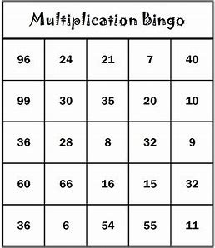 | - If you need to create your own bingo board. Make a grid shape 5x 5 is a good start and fill with lots of numbers from 1 and up. Make different boards so there will be one winner.  - Choose who is playing first and they roll the dice.  - Multiply the two numbers together and if it matches with any of the numbers on the board then place a counter.  - For example, if you roll a 2 and a 4 and if you have an 8 then place your counter.  - The first to get a line wins a round then the first to get a full board is the overall winner.
Further learning | Try the same bingo board but with division instead.

For hygiene reasons please ensure you wash your hands and any objects you have been touching after you have finished the activity.

