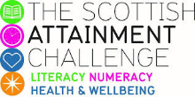
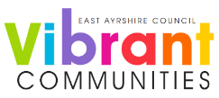

Scottish Attainment Challenge

Mentoring Development Officers Activities

Activity Title: | All About Me Flag
Age range: | P7+
Area of the Curriculum: | Art, wellbeing
Resources required: | Paper, pens, pencils.
Time / length of the activity: | 30 minutes +
Number of people required: | 1+
Instructions:  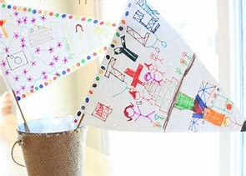 | - Flags can symbolise many different things from countries to events or raising awareness.  - To create your own, have a piece of paper, A4 is a good size and draw a cross on it to create 4 boxes. Or you can create a triangle and add lines to create different areas.  - Think of 4 different ideas you want to share about yourself, is it your favourite place, food, song, animal or hobby.  - In each of the boxes, pick one topic to create a picture, you can make it as detailed as you want.  - Add a border of your favourite colours or you could add patterns between each of your images.  - This flag is to represent you and things that things that mean something or are important to you including the colours.  - You could use one of the boxes in your flag to show who inspires you or a motivational quote that you have fond useful.
Further learning | Pick a flag that you like it could be a country or a raising awareness campaign and do some research about the colours and symbols used.

For hygiene reasons please ensure you wash your hands and any objects you have been touching after you have finished the activity.

