Kim’s game

This is a memory game.
You put a selection of small items on a kitchen tray.
For example, a pencil, a spoon, a hairbrush, a cup, a small toy etc
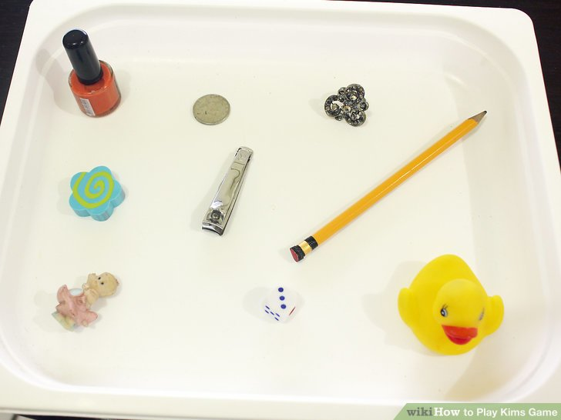
Give each child a pencil and paper.
Let them look at the tray for 30 seconds, then cover it with a tea towel.
Each child has to write down what they remember as being on the tray.
The child with the most correct items listed is the winner.

