Fun at home:
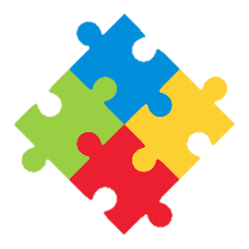
Activity: Pebble Alphabet /Scrabble

You will need: pebbles/small stones
permanent markers/paint

How to play: Pick nicely shaped
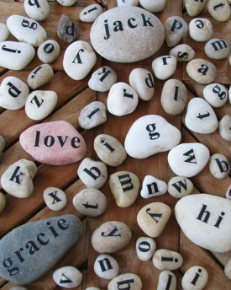
pebbles or small stones; clean and dry them. Next, with a permanent marker, write the letters of the alphabet on them, make sure you collect enough stones to have several alphabets and also more of the most used letters ( you will need more “E” and “S” for instance than “Z”! Invent fun word games (longest word, funniest word, foreign language word) or play scrabble and create your own word search.
Literacy and Numeracy activities

# ScottishAttainmentChallenge
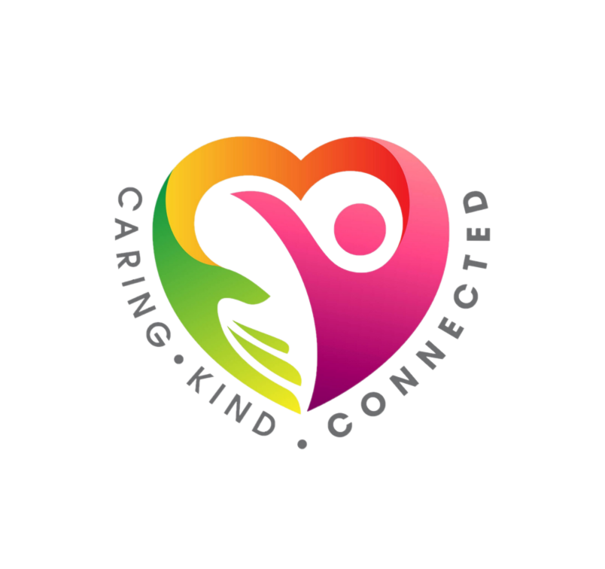
#Family and Youth Literacies

