Fun at home:
Activity: Straw Drawing Illustrated
Storybook

You will need: water colour, straws
paper, pens, scissors

How to play: Think of a story; you can start by
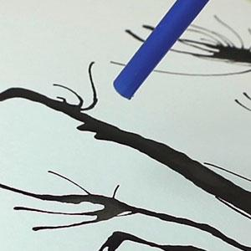
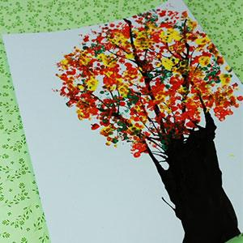
writing down the story first or draw your
pictures and then write the story, whichever you prefer. To illustrate your storybook, put a little bit of very watery paint on the page, blowing gently through a straw to make patterns on the paper. Finish off your illustrations with pens or markers.
Literacy and Numeracy activities

# ScottishAttainmentChallenge
#Family and Youth Literacies

