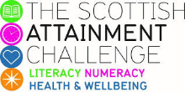

Scottish Attainment Challenge

Mentoring Development Officer Activities

Activity Title: | Creative chalking
Age range: | All
Area of the Curriculum: | Art, English
Resources required: | Chalk and a surface outside to write on.
Time / length of the activity: | 30 minutes +
Number of people required: | 1+
Instructions:  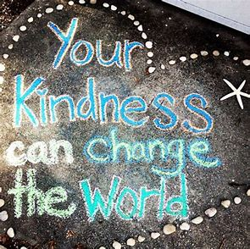 | - Look up some positive quotes online, there are lots to choose from.  - You can choose ones that are as short or as long as you like, they can be inspirational or can be to share a positive message.  - Use words that are kind and no offensive language or you will put people off reading what you have wrote.  - Then get chalking on a pavement or a wall, add some shapes, artwork or a border to create interest.  - You could chalk on the outside of your house, on the pavement close to home or in a local park. The great thing about using chalk it washes off.  - You might want to raise awareness about something you feel passionate about, there are many things going on in the world today that you could choose from.
Further learning | Why don’t you try creating some of your own positive quotes or sayings?  Or do some research about issues which impact on young people and create a positive awareness chalk event.

For hygiene reasons please ensure you wash your hands and any objects you have been touching after you have finished the activity.

