Fun at home:
Activity: Crazy Stories

You will need: card, dice template,
scissors, glue, marker, pen+ paper

How to play: draw, cut out and glue
the template to make your dice. Next write instructions on each side of the dice:
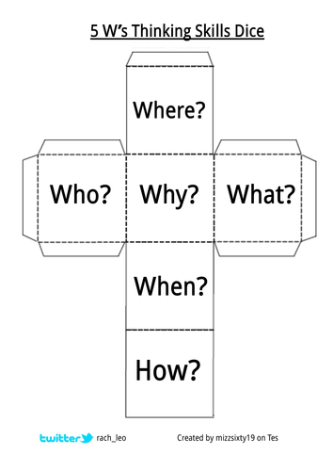
“Where, Who, Why, What, When and How” Players, in turn, throw the dice and write down the answer to the question they landed on. After 5 rounds of throws; as a team, they must write a story using all the answers given. The crazier the story, the better!
Collate a “Book of Mad Stories”!
Literacy and Numeracy activities

# ScottishAttainmentChallenge
#Family and Youth Literacies

