Fun at home:
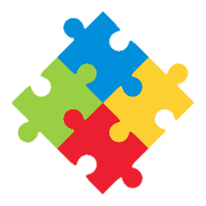
Activity: Table Football

You will need: a box or crate, clothes
pegs, round wooden spars, small
light ball (table tennis ball is best)

How to play: Using the picture to
guide you, cut holes in the crate or
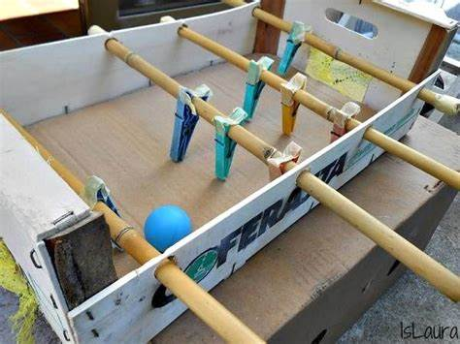
box, put the spars through the holes, next attach the pegs to the spars to make the players and finally, cut a hole at each end of the box to make the goals. You can personalise your game in the colours of your favourite team. Put the ball in play and you are ready for kick off

Literacy and Numeracy activities

# ScottishAttainmentChallenge
#Family and Youth Literacies

