Fun at home:
Activity: Personalised Happy
Families Card Game

You will need: Card, scissors, glue,
pictures or photos, markers, ruler

How to play: Choose your 7 families
You can base your game on your and
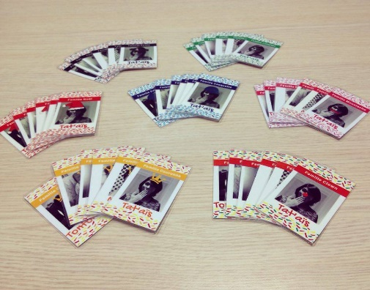
your friends families or animal, super hero and cartoon characters families. Each family has a father, mother, son, daughter, grandfather and grandmother. Draw all your cards or glue pictures and family photos if you prefer. Name your families, cut out your cards and you are ready to play
Literacy and Numeracy activities

# ScottishAttainmentChallenge
#Family and Youth Literacies

