Fun at home:
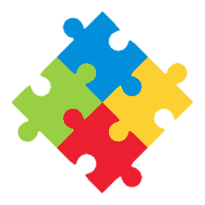
Activity: Musical Glasses

You will need: glasses, water,
spoons, food colouring (optional)

How to Play: line up the glasses,
Fill them with descending levels of water, adding colour if you like. When you tap the glasses with a spoon, they will all play a different note. Add or pour out more water till you get the notes you want.
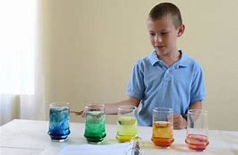
With some practice you will soon be able to play your favourite tune
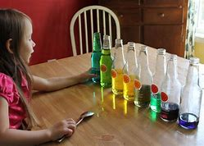
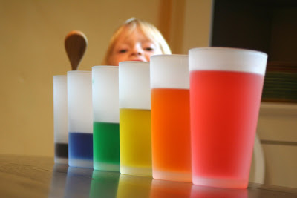

Literacy and Numeracy activities

# ScottishAttainmentChallenge
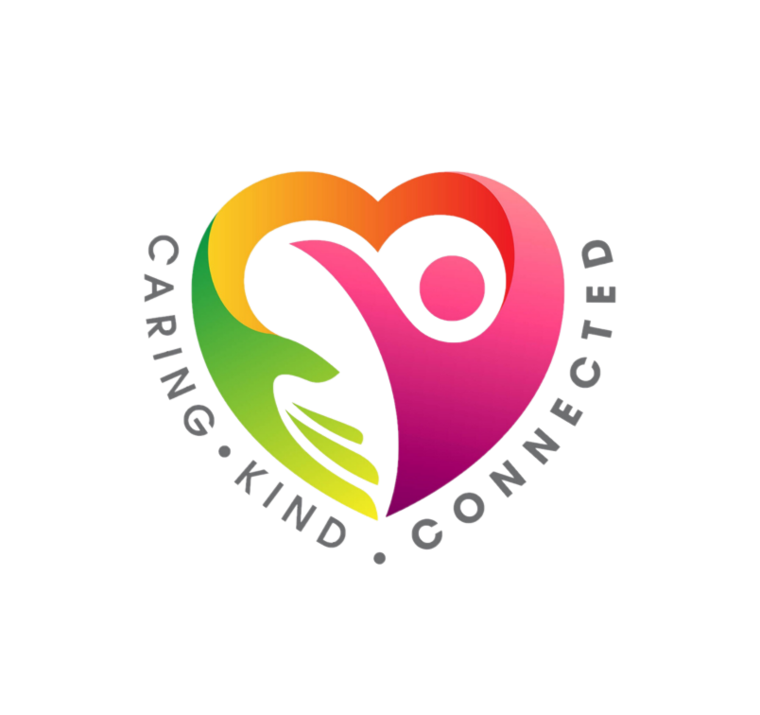
#Family and Youth Literacies

