Fun at home:
Activity: 100 or Bust !

You will need: 2 dice

How to play: Each player in turn
rolls the dice and adds up his total.
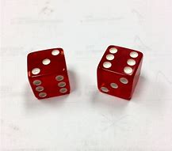
The first player to reach 100 wins the game. If a player goes over a 100 with his last throw, he is eliminated. If no player manage to reach a perfect 100 score, the winner will be the player who gets nearest to 100 without going over!

Literacy and Numeracy activities

# ScottishAttainmentChallenge
#Family and Youth Literacies

