Fun at home:
Activity: 3D Polar Bear and Panda

You will need: card, cotton wool,
glue, black markers, paper cups,
buttons, scissors
How to Play: cut out a card face
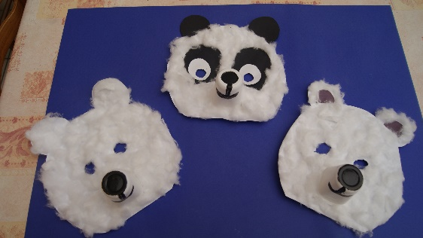
and ears; next glue the ears to the face, glue the cotton wool to make the fur; make a snout with a paper cup, draw a nose and mouth on the cup with the black marker;
draw black ears and eyes for a panda; glue on the buttons for eyes. If you make 3 bears, you can reinvent the new story of “The Adventures of Goldilocks and The Three Polar Bears in The Arctic!”
Literacy and Numeracy activities

# ScottishAttainmentChallenge
#Family and Youth Literacies

