Fun at home:
Activity: Colour Pencils Xylophone

You will need: Colour pencils, glue
or sticky tape, bits of wood, plastic
(or rulers) for the frame, sharpener
How to play: Fasten your colour
pencils in descending lengths on
the frame you made with the wood
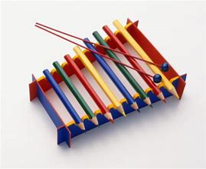
or plastic. (sharpen your pencils till they are the size you want). When they are tightly secured with glue or sticky tape, you are ready to start playing

Literacy and Numeracy activities

# ScottishAttainmentChallenge
#Family and Youth Literacies

