Fun at home:
Activity: Under The Sea Frieze

You will need: large sheet of paper
markers, paints, stickers, scissors,
glue, magasines, pictures

How to Play: to create a large Under
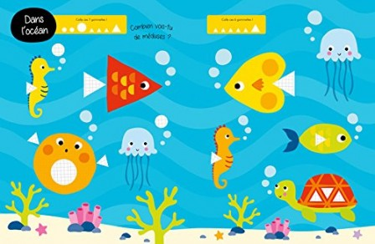
The Sea frieze, draw all kinds of sea creatures, ( fish, crabs, turtles, jelly fish, sea horses, seaweed) You can add cut out pictures, anything you like. When your frieze is complete, put it up on your wall. Keep adding extra marine life whenever you want to.
Literacy and Numeracy activities

# ScottishAttainmentChallenge
#Family and Youth Literacies

