Family Literacy – Scottish Attainment Challenge

Mentor Development Officers Activities

Activity Title: | Positivity Pot
Age range: | Primary 7+
Area of the Curriculum: | Wellbeing
Resources required: | Paper, pens/pencils, pain and a jar (Jam or candle)
Time / length of the activity: | 30 minutes to create
Number of people required: | 1+
Instructions:  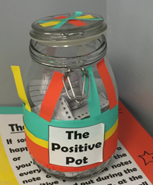 | The Positivity Pot is somewhere to store all the great things you have in life. Anytime you think of something that was goo d that day take a not (make it as colourful and creative as possible) and add it into your pot.  Once your pot is full, read through them to highlight how positive things are and what great things there are in life.  Design your positive pot whatever way you like – make if colourful and welcoming to encourage you to add to it.
Further learning | Once you read through your Positivity Pot try creating a happy story about the things you read.

For hygiene reasons please ensure you wash your hands and any objects you have been touching after you have finished the activity.

