Family Literacy – Scottish Attainment Challenge

Mentoring Development Officers

Activity Title: | Mega swamp map
Age range: | S1+
Area of the Curriculum: | English, Communication
Resources required: | Paper and pens
Time / length of the activity: | 30 minutes
Number of people required: | At least 2
Instructions:  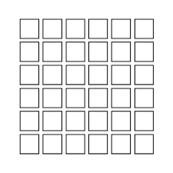 | - First you need to decide how big you want your map to be i.e. how many pieces of paper you want to use to make a giant square or rectangle  - Place the pieces of paper in a straight rows across the floor to make a giant grid like pattern. 6x 6 is a good size to start with.  - Make a smaller grid on one piece of paper this is your map, making sure you have the same amount of squares and rows as the floor grid.  - Fill in some of the squares to create a pathway or pattern through the small map. Up, across and diagonally. Making sure that only one person knows the correct path.  - Now the other person or teams has to guess the correct pathway.  - The aim is to avoid the incorrect pathway as this means you have been swallowed up in the ‘swamp’ and have to start again.  - If the person gets the right square then they can have a guess at the next one and so on.  - Whenever someone gets a wrong square then they start back at the beginning and someone else tries.  - It’s a good idea if you try to remember what pathway yourself and others have taken as this will help when it comes to your turn again.  - If playing with more than one person make sure to make different maps.
Further learning | Use a stopwatch to time and see how long it takes to get through the ‘swamp’ safely to beat the other person or team.  Get creative and add your own swamp creatures or plants made from card or cardboard to surround your floor map to add some fun.

For hygiene reasons please ensure you wash your hands and any objects you have been touching after you have finished the activity.

