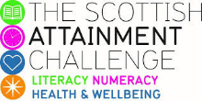

Family Literacy – Scottish Attainment Challenge

Home Learning Activities

Activity Title: | Engineering challenge build your own structure
Age range: | P7+
Area of the Curriculum: | Stem
Resources required: | Newspaper, straws and tape. You can add one or two other items if you wish but the less the more challenging it is.
Time / length of the activity: | 30 minutes or longer depending on how big the structure is.
Number of people required: | Any number
Instructions:  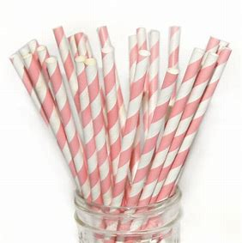 | - Build a structure that can support itself this can be a bridge, sculpture or tower, decide before building it.  - Using just the materials provided the aim is to build as big or sturdy a structure as possible.  - The winner is the one who has the tallest if it’s a tower that stands on its own using  - Or if it’s a bridge it is free standing and can fit a tin under it and hold a little weight decided how heavy before starting.  - Make it a competition and go into teams.
Further learning | Make a structure from different materials such as craft sticks, pegs and binder clips, see if it is possible to create different shapes.

For hygiene reasons please ensure you wash your hands and any objects you have been touching after you have finished the activity.

