Family Literacy – Scottish Attainment Challenge

Mentoring Development Officers

Activity Title: | Make your own DIY projector
Age range: | P7+
Area of the Curriculum: | Stem
Resources required: | Small cardboard box, a magnifying glass, scissors, tape and a smart phone
Time / length of the activity: | 20 minutes
Number of people required: | 1 or more
Instructions:  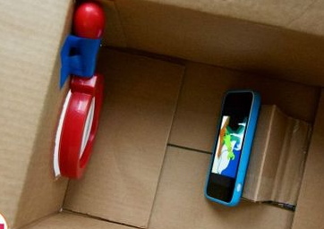 | - Place the magnifying glass on the front of the box and trace round it.  - Then using the scissors cut a hole in the box just slightly smaller than then traced circle.  - Then using a spare piece of cardboard fold it to make a stand for the phone, keeping it in place with some tape.  - Slide the phone stand into the box under the flap at the bottom of the box.  - Next tape the magnifying glass inside the box so that the lens is matching with the hole in the front.  - Lock the phone onto landscape orientation.  - Add the smart phone on the stand upside down in the projector.  - Point the projector at a white or light coloured wall and focus the picture by moving the phone away or towards the lens until the picture is clear.  - Turn down the lights and watch your chosen film.
Further learning | Find out the science behind it and what makes it work.  Or do some research on the films you chose to watch, the director, when it was made, what genre it is.

For hygiene reasons please ensure you wash your hands and any objects you have been touching after you have finished the activity.

