Family Literacy – Scottish Attainment Challenge

Mentoring Development Officers
Activity Title: | Create your own comic strip
Age range: | S1+
Area of the Curriculum: | 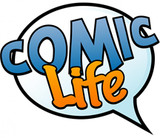  English, Art, Digital Media
Resources required: | Comic Strip app, paper and pens
Time / length of the activity: | 1 hour
Number of people required: | 1
Instructions:  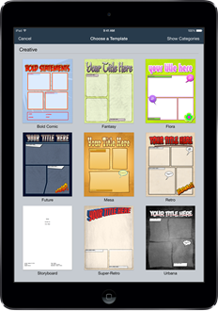 | - Download Comic Strip on Google Play or the Comic Life on the App store onto a phone or tablet device.  - Note some ideas on paper, you could even draw your own comic strip, planning what you want your story to be.  - Next open up the app you have downloaded and select a comic strip design there is lots to choose from.  - By clicking on certain areas within the comic strip you can take photos and add speech into the bubbles to create a story and make your own title.  - Some ideas could be what life is like in lock down, or take pictures of your family to create a story. You could also create a how to guide of making something or cooking.  - You can then save your comic strip and then move on, create another or as many more as you like.  - Don’t worry if you make a mistake a photo can easily be taken again until you are happy with the right one.  - You could share some ideas with friends and family and get them involved in creating a comic strip.  - Have fun creating your own comic strips.
Further learning | Research some history on comic strips, Marvel and Dc are a good place to start, the superheroes you see in films are all based on characters within comic strips.

For hygiene reasons please ensure you wash your hands and any objects you have been touching after you have finished the activity.

