Fun at home:
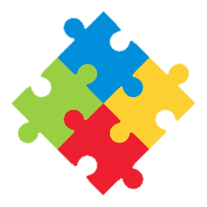
Activity: 3D Paper Plate Seascape

You will need: paper plates, paper,
paint, stickers, scissors, glue

How to Play: paint a blue sea and
sky background on the paper plate.
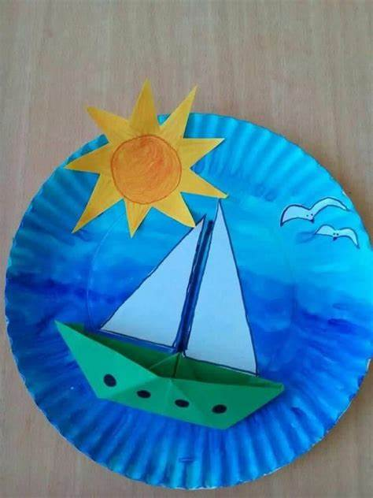
Make an oregami boat and glue it on the plate. Next draw, cut out and glue on the sails, a sun and sea birds. If you don’t know how to make a paper boat, ask an adult for help or simply draw a boat. Add any finishing touches you like...and sail away
Literacy and Numeracy activities

# ScottishAttainmentChallenge
#Family and Youth Literacies

Fun at home:
Activity: Oregami Boat

You will need: A4 sheet of paper

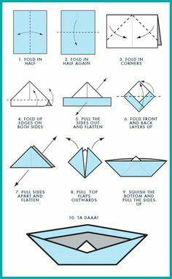

How to Play: Follow instructions as shown on the picture to make your oregami paper boat for a 3D paper plate seascape.
Ask an adult for help if you need to...
Literacy and Numeracy activities

# ScottishAttainmentChallenge
#Family and Youth Literacies

