Lego blocks
In a nutshell – Good, old lego! Useful in so many ways and here it comes to the rescue again.

Prepare some cards with colourful blocks on them and let your little
one discover colour patterns and recreate them with LEGO blocks.
They could even do the colouring!

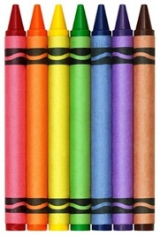
What you need:
Lego
Paper
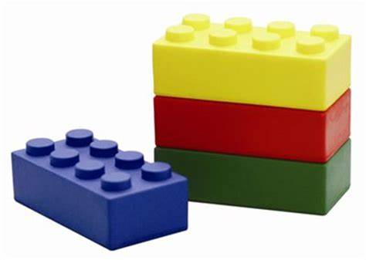
Colouring pencils/pens/crayons

