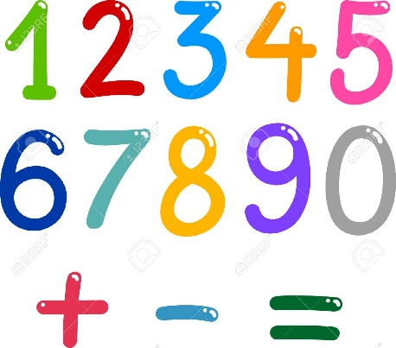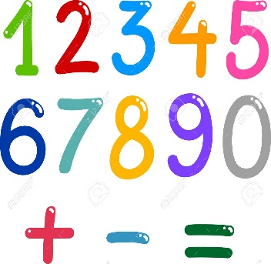Spinning cups

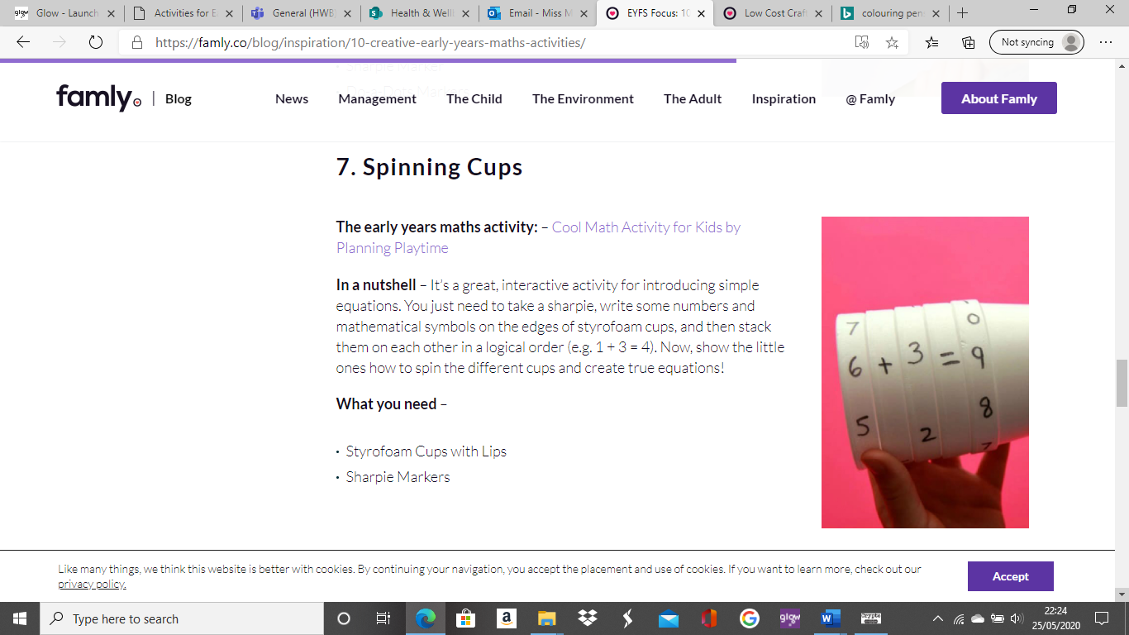

What you need:

Sharpie pen (biro pen would work also)

Polystyrene/paper cups

It’s a great, interactive activity for introducing simple sums. You just need to take a sharpie, write some numbers and mathematical symbols on the edges of the cups, and then stack them on each other in a logical order (e.g. 1 + 3 = 4).

Now, show the little ones how to spin the different cups and create some sums!