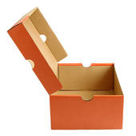
Create a Covid-19 Time Capsule

A time capsule is any container which holds artefacts that represent a specific time.
The container could be anything from a shoe box, a wooden storage box, a glass jar or an actual capsule, and you can decorate it however you wish. You could even use your school bag!
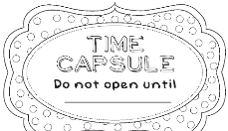
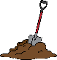
After filling the container, it should be hidden away to find in the future. If it's weather proof and not biodegradable, you could dig a hole in the garden and bury it. Or, it could be buried somewhere inside – among the random stuff in the attic or hidden at the back of a cupboard!
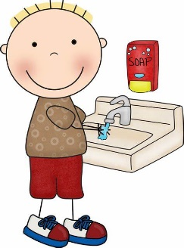
It's up to you how long you wait before opening it up again!
Set a date and stick to it!
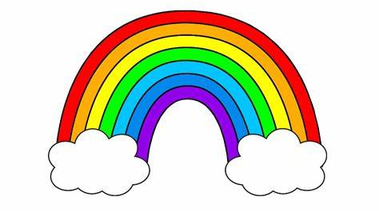
You can include items such as:
- Photos of what you look like now.
- Pictures of rainbows, stay safe pictures and drawings.
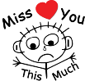
- Newspaper and magazine clippings of the biggest coronavirus stories and most memorable headlines, including the positive ones!
Letters or cards you might have received from family members you haven't been able to see
- Photos or pictures of things you've been doing in homeschool and to have fun.
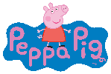
- A list of what your favourite things are at the time, such as your favourite food, colour, TV show or game.
- A note of who your best friends are at the moment and what you want to be when you're older.
- Painted handprints, a note of how tall you are and how old you are.

The great thing about creating a collection of memories like this is that the container can be filled with whatever you like, especially things that mean something special or unique to you.
So what are you waiting for? It's time to get collecting!

