Family Literacy – Scottish Attainment Challenge

Mentoring Development Officers

Activity Title: | Mint tin history report
Age range: | S1+
Area of the Curriculum: | Art and History
Resources required: | Card, scissors, paper, pens, glue and if you have one a small mint tin (this ideal) or box
Time / length of the activity: | 1.5 hours
Number of people required: | 1
Instructions:  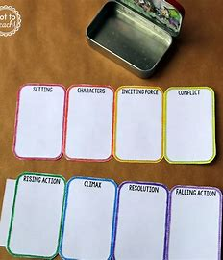 | - Choose someone from History that interests you, it can be anyone.  - Do some research online about the person and take a notes, not too may as remember it’s a mini report.  - Use your small tin or box to draw round (making about 6-8 pages) on a large piece of paper in a row, make two rows of 3 or 4.  - Then cut round the template making sure you don’t cut down the middle so all the pieces are joined.  - Or if you don’t have a tin then cut paper to make a small booklet and glue it together.  - Give each page of your report a title, time period, what the person did, early life, what are they known for, who they influenced and any other interesting facts you have found.  - Write your information and facts.  - Fold your mini report and store it in your tin or envelope.  - Get creative and decorate the tin/box or the cover of your report.
Further learning | Create your own quiz on people from History and test family and friends.  Or make a mini report on favourite book or film, why you like it, who were the characters and what was the plot.

For hygiene reasons please ensure you wash your hands and any objects you have been touching after you have finished the activity.

