Fun at home:
Activity: Cup and Ball Game
( Catch the Fish)

You will need: a plastic bottle
stickers, string, a ball or small toy
How to Play: Cut off the top 1/3 of
the bottle (ask an adult to help)
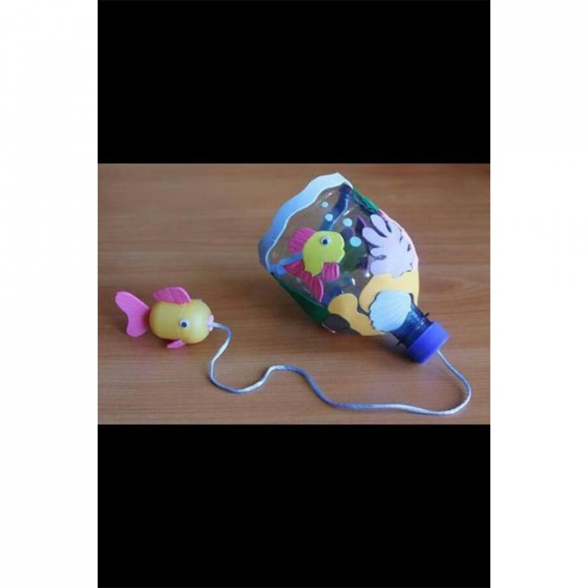
Decorate with stickers, then tie one end of the string to the cap of the bottle and the other to the toy of your choice (a bath toy for an Under the Sea theme!).
You must now catch the ball or toy with the bottle.
How many attempts did you need?
Literacy and Numeracy activities

# ScottishAttainmentChallenge
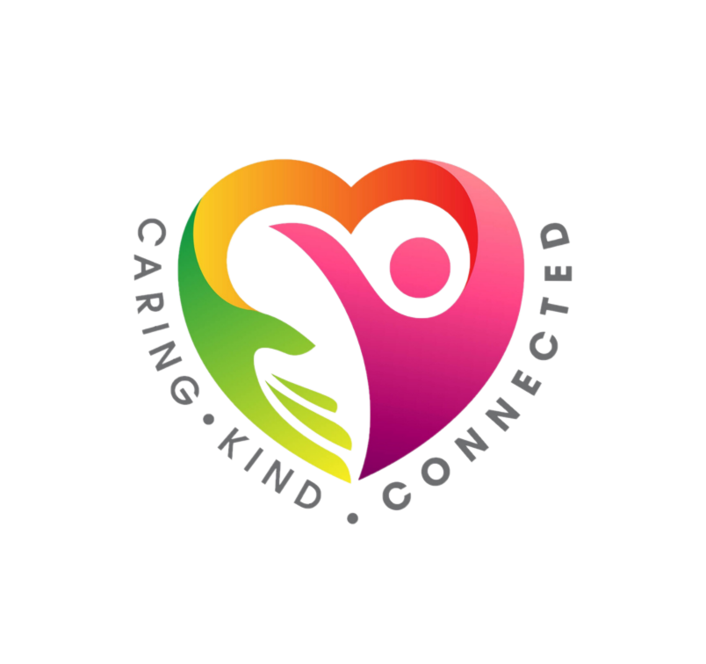
#Family and Youth Literacies

