Family Literacy – Scottish Attainment Challenge

Home Learning Activities
Activity Title: | Make your own worry dolls
Age range: | P7+
Area of the Curriculum: | Art
Resources required: | Craft pegs or ordinary wooden or plastic pegs will do, embroidery thread or fine wool, glue, scissors and pens.
Time / length of the activity: | Approximately 30 minutes.
Number of people required: | Any number
Instructions:  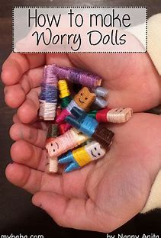 | - Choose three different colours for your worry doll.  - Starting at the top add a little glue then press the end of the first thread to it.  - Wind the thread around the top third of the peg, when there has been enough wound round then add a little glue to the end of the thread and press down to make it stick.  - Repeat this for the next two colours, when you get to the legs you can wrap them individually or not.  - Add a little glue to the top and the bottom of the peg where the thread is at the end of the peg to stop it coming off.  - Finally add a face using a pen.
Further learning | Research where worry dolls came from and why they were made.  Make a little box out of card to keep your worry dolls in.

For hygiene reasons please ensure you wash your hands and any objects you have been touching after you have finished the activity.

