Family Literacy – Scottish Attainment Challenge

Home Learning Activities
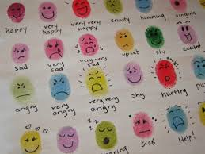
Activity Title:
Thumbprint Emotions
Age range: | P7+
Area of the Curriculum: | English/Art
Resources required: | Paper, paint and pens
Time / length of the activity: | 30 minutes
Number of people required: | Any number
Instructions:  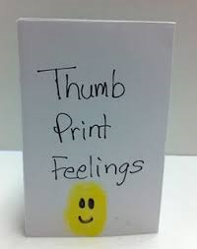 | - Fold the paper several times or stick a few pieces of paper together so you have a booklet or you can use a large bit of paper.  - Dip your thumb in the paint and then print it on the paper.  - Draw a face or expression on it showing an emotion for example angry.  - Get creative and add as many details or as few as you like, arms and legs etc.  - Then write about the feeling or emotion you have drawn on your thumbprint character. For example what makes you angry?  - Keep doing this with as many emotions you can think of using different colours and expressions.  - Write about how you are feeling using your character to express yourself.
Further learning | Make a story out of thumbprint characters, give them names, personalities and what kind of things they like to do related to the feeling or expression.

For hygiene reasons please ensure you wash your hands and any objects you have been touching after you have finished the activity.

