Fun at home:
Activity: Shadow Puppets Show

You will need: card, scissors, glue,
pencil, wood skewers or straws
a light, a white wall.
How to Play: Draw your puppet
outlines on the card, cut them out and glue on the skewer or straw as a handle. Shine your light on the puppets to cast a shadow on the wall. The show can begin...
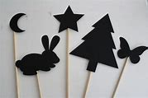
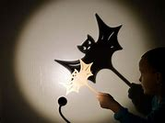
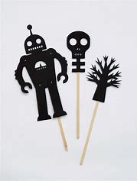

Literacy and Numeracy activities

# ScottishAttainmentChallenge
#Family and Youth Literacies

