Fun at home:
Activity: Catch the Ball

You will need: 2 large plastic bottles
with a handle (milk bottles are best!)
markers or tape, a small ball
How to Play: cut the clean bottles in
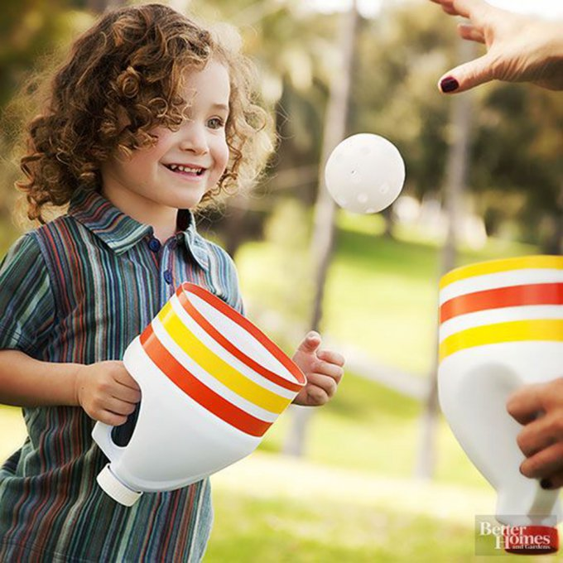
two (ask an adult to help), decorate them with markers or tape.
The players must throw and catch the ball using the containers. Count how many catches you can score without dropping the ball.
Highest score wins the game.
Literacy and Numeracy activities

# ScottishAttainmentChallenge
#Family and Youth Literacies

