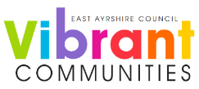
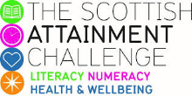

Family Literacy – Scottish Attainment Challenge

Mentor Development Officers Activities

Activity Title: | Secret Sugars
Age range: | S1- S3
Area of the Curriculum: | Numeracy and Wellbeing
Resources required: | Paper, pens/pencils and internet access
Time / length of the activity: | 30 minutes +
Number of people required: | 1+
Instructions: | Research the amount of sugar in different food types and create an awareness poster showing how much sugar is in the food.  Fruit Crisps  Apples Strawberries Grapes Kiwi Banana Water Melon Monster Munch Pickled Onion Salt and Vinegar Walkers Baked Tangy Cheese Doritos BBQ Pop Chips Golden Wonder Ketchup Cheese & Onion McCoys  Chocolate Drinks  Mars Bar Twix M& M’s Snickers Terry’s Chocolate Orange Milky Bar Water Red Bull Lucozade Coca-Cola Irn-Bru Milkshake  Veg Cereal  Carrots Peppers Sweet Potato Peas Onions pumpkin Corn Flakes Frosties Rice Krispies Cheerios Cookie Krisp Coco Pops
Further learning | Use real sugar and measure the amount in each food and add this to your poster.

For hygiene reasons please ensure you wash your hands and any objects you have been touching after you have finished the activity.

