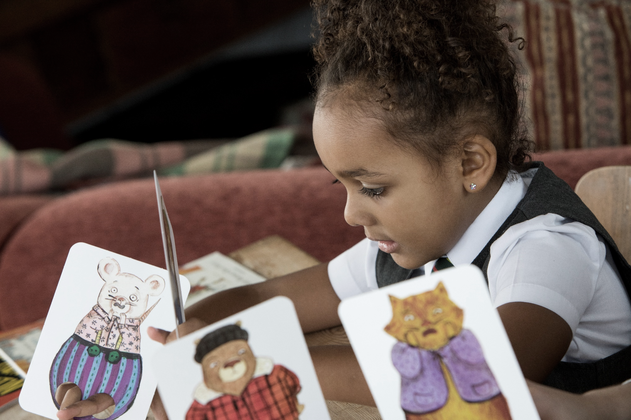
Resource created by Ailie Finlay

Primary 3 inclusive and sensory resource
Age 6-7

CFE First Level

scottishbooktrust.com

/scottishbktrust

@scottishbktrust

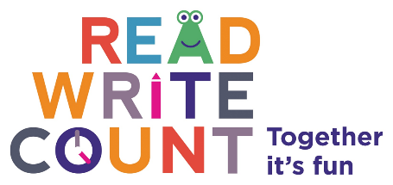

Contents
You’re Called What?! activities 2
The Knight Who Said ‘No!’ activities 2
Galactic fantastic activities 4
Story card activities 4
Routine card activities 5
Multisided dice activity 5

How to use this resource
The aim of this resource is to make the items in the Primary 3 Read Write Count bag accessible to all. The activities in this resource are for pupils with a variety of needs, including additional support needs, English as an additional language and those disengaged from reading.
These activities are flexible and are for use in both the classroom and the home. Teachers and learning professionals are welcome to share these activities with parents and carers in whatever method is most appropriate to your setting.

You’re Called What?! activities
Texture cards
Make some texture cards by sticking squares of fabric, card etc. to card. Ask the child: ‘What do you think X [point to character] feels like? They can then choose the texture card that they feel is the best match. This game is not necessarily about having the right answer but about starting a conversation.
Textures for cards might include:
- Fur fabric
- Corrugated cardboard
- Sequinned fabric
- Feathers
- Sandpaper
- Lycra fabric
- Sponge
If you do not have time to make cards, you could just talk about the textures in the books. You could ask question like:
- Who do you think is the slimiest?
- Who do you think is the softest?
- Who do you think is the hardest?

Act a snippet of the story
Using the illustrations as inspiration, collect together ‘office equipment’ such as sticky notes, paper, pens, coffee cup, ink stamp, toy phone, tape, forms, binders etc. and set up an office on a table and in pairs act out a scene from the story. One of you works at the ministry; the other is applying for a name change. Role-play the form filling in, stamping documents and so on. ‘Pretend’ writing on the forms is absolutely fine! The person applying for a new name can invent a silly name they want to change.

The Knight Who Said ‘No!’ activities
A castle for Ned
Ned lives in a big castle. Make a castle for Ned out of old boxes and cereal packets. You could use other play items such as Lego too. Add a little Ned character at the top of the castle, a mum and dad in the middle of the castle and some soldiers and villagers all around. The characters can be cut out of card or paper, and then stuck to the castle with blue tac or a loop of tape (or use Lego or Playmobil figures). You can then re-tell the story using the little figures.

What is that job?
Ned does many different jobs. Can you act out some of the jobs and see if people can guess what you are doing? What other jobs might he have to do in a castle? Think of some jobs that are not in the book and act these ones out as well. Can anyone guess what you are doing?

Yes and no!
Read through the book looking carefully at the pictures, but this time only read the words ‘yes’ and ‘no’! Try to make them full of expression!
Role-play having a ‘yes’ day. One person asks the other to do many jobs. They reply ‘yes’ to everything and mime the actions.
Then role-play a ‘no’ day. This time say ‘no’ to everything!
Which do you think is more fun?

Make a sensory castle corner
Gather together props and objects for a castle corner. Do not worry too much about historical accuracy! These might include:
- Special ‘royal’ fabric
- Rugs
- Rough blankets
- Toy spiders and cobwebs
- A ‘throne’ (made from a chair draped in fabric)
- A fan (to make draughts!)
- Costumes and crowns (but best not include any swords etc.)
- Drums
- Soft toys (cats, dogs, chickens)
- If possible, a dragon!

Galactic fantastic activities
Make your own alien
Using the alien cards as inspiration make some aliens out of the contents of your recycling box. Or you could use plasticine or a soft air-drying clay if you have some. What special powers do your aliens have?
You could make some simple alien cards with just a picture, name and the ‘special skill’ category. Then play Galactic Fantastic as outlined but using just this one category.

Story card activities
Character charades
Choose a card and act out the character. Everyone has to guess who you are!

Story map
Draw a map of your ‘story land’ on a large piece of paper. Include some of the settings from the story cards such as beach or castle. Alternatively, you could actually tape or blue tac some of the settings cards lightly to your map.
Everyone takes a character card and chooses which setting their character is going to. This is more fun if you choose at random; you could put the cards face down on a table and take turns to choose.
The character cards are placed on the map. At this point either the adult or the child can describe a ‘problem’ for each character in their chosen setting.
For the next round, each character has to resolve their ‘story’- possibly with the help of another character.
For example:
I have the unicorn character. I choose to journey to the castle. But when I am there, I see a ghost. I ask the cat for help and the cat creeps up on the ghost and scares it and we get away.
I have the dragon character. I choose to go to the party. But nobody wants me there because I am so big and clumsy. Then everyone realises there are no matches to light the cake. I am able to help! Everyone is glad I came after all.
This can also be acted out in space by taping the setting cards to different parts of the room. In this version, you carry your character card to your chosen setting and then act out ‘what happened next’. After you have resolved your story, you carry your character ‘home.’

Making friends and enemies
This is a game for two players. Each player chooses a character card. The players approach each other and ‘meet’ as their characters. They then have a quick discussion, decide ‘what happens next’ and act it out.
Helpful questions might be:
Is one of you scared of the other one?
Are you going to be friends?
Do you go on together or say goodbye…?
Be very clear before starting this game that no violence or running are allowed.

Routine card activities
Match the object to the activity
Gather together some objects that go with the activities on the cards, such as a lunch box, teddy, pillow, skipping rope, book. Ask the child to match the objects to the cards. Which activities happen in the daytime and which happen in the night? Perhaps you can say whether the activity happens in the morning, afternoon, evening or night-time…?

A perfect day
Make some more simple activity cards together of things the child enjoys doing. Put these cards in sequence to create the ‘perfect day’.
For example:
Get up, go swimming, have lunch, go to the park, have tea, play computer games, go to bed.
You could try creating activity cards and ‘a perfect day’ for other people as well (a friend, your mum, your baby sister). How would these be different from ‘your’ day?

Multisided dice activity
Energetic dice
Play this game in pairs. One person decides on a simple action such as jump, touch your toes, pat your head, star jump. The other person rolls the die and whatever they roll they do the action that number of times. (It is not recommended to do this with the red die!

