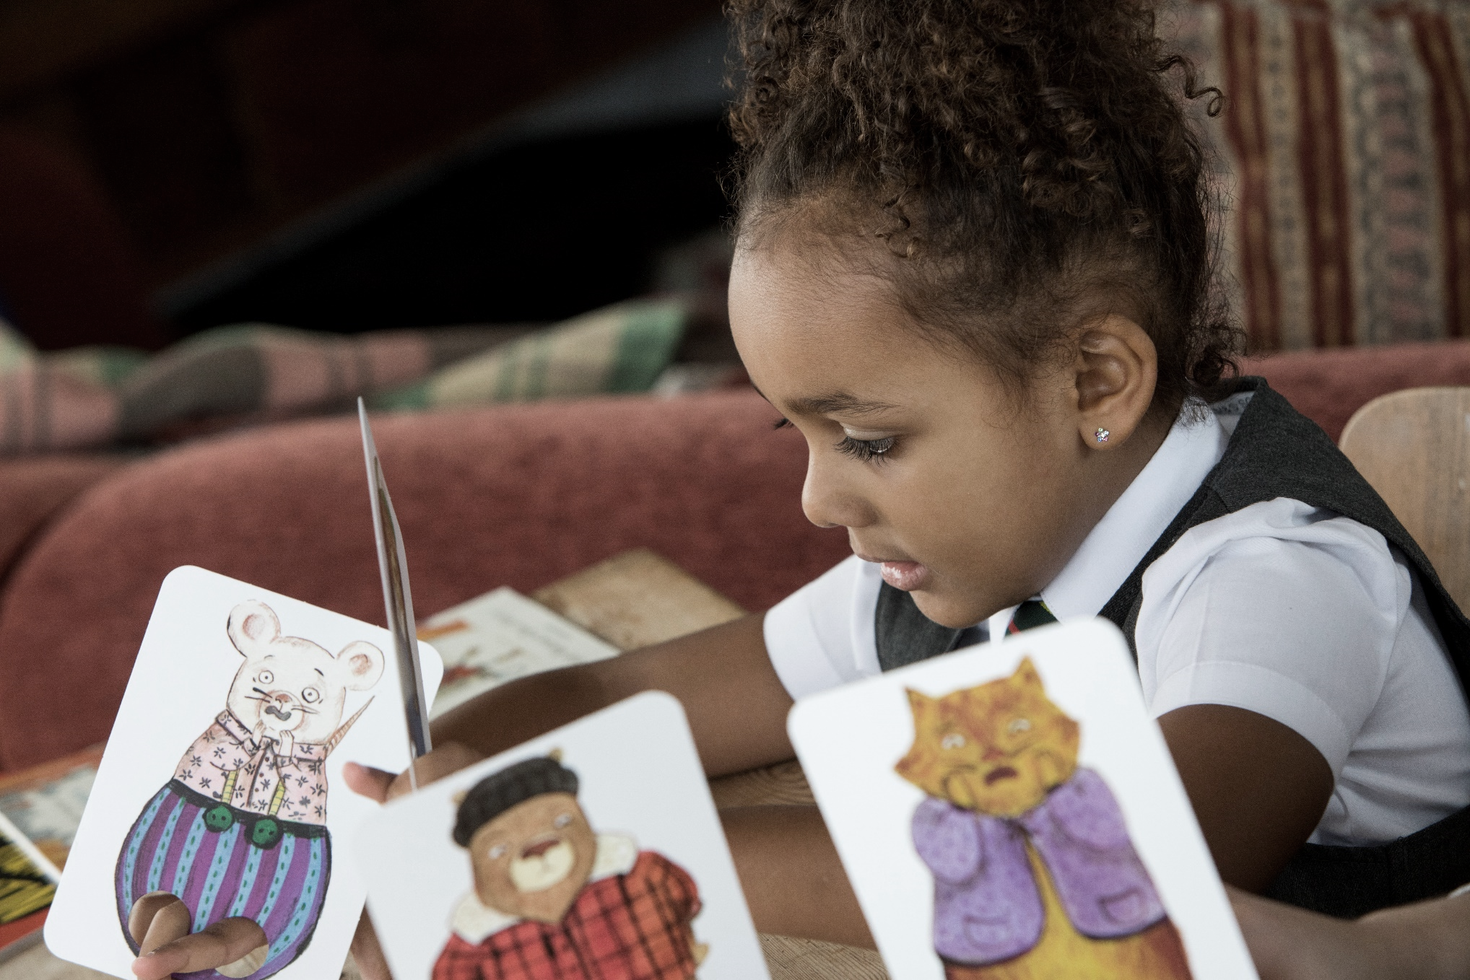
Resource created by Ailie Finlay

Primary 2 inclusive and sensory resource
Age 5-6

CFE First Level

scottishbooktrust.com

/scottishbktrust

@scottishbktrust

Contents
Steve, Terror of the Seas activities 2
The King Cat activities 3
Story cube activities 4
Rockets and meteors activity 5

How to use this resource
The aim of this resource is to make the items in the Primary 2 Read Write Count bag accessible to all. The activities in this resource are for pupils with a variety of needs, including additional support needs, English as an additional language and those disengaged from reading.
These activities are flexible and are for use in both the classroom and the home. Teachers and learning professionals are welcome share these activities with parents and carers in whatever method is most appropriate to your setting.

Steve, Terror of the Seas activities
Puppets
Make simple puppets of fish by drawing them onto strong paper, cutting them out and sticking them on to sticks or strong straws with tape.
It is fun to use these puppets to put on a little table-top puppet show. Instead of the puppet being held from below (as is usual for these kinds of puppets), the stick or straw is taped so that it is sticking up and the puppet is held from above. Think of a string puppet but with a stick rather than a string.
Decorate a table with some scenery such as seaweed, stones etc. These could be cut out of card and propped up, or you could use real stones. Then act out a simple puppet version of the story where the ‘Steve’ puppet is swimming and all the other fish come ‘on-stage’ one by one and react as if they are scared of him. At the end the big shark can appear.

Watery story time
Re-tell a simple version of the story in the bath or using a tub of water. You could cut the different characters out of sponge cloths. Alternatively, just improvise with what you have around…toys, scrubbing brushes etc.

Down at the bottom of the deep blue sea
Collect toy fish, turtle, jelly fish etc. Put them in a large drawstring bag. The children chant (as in ring-a-ring-a-roses):
Down at the bottom of the deep blue sea
Catching fishes for my tea

Each child takes it in turn to ‘fish’ in the bag with their hand- but not looking! If they like they can guess what they have caught before they pull it out.
Each ‘fish’ is asked as it is caught:
Are you going to swim away from Steve?
To which they all answer ‘yes’. Until the last fish – which is the George shark. He answers:
No! Steve is my friend!

Tell a tactile story
Use tactile props to tell a version of the story. Each fish will need to have a particular tactile quality, which you can add into the story. Here are some examples:
Small shiny fish: anything made of smooth shiny or sequinned fabric
Big fish with sharp teeth: a large comb
Jelly fish with their long tendrils: strips of fabric or a silky scarf, which you can dangle and brush against people.
Puffer fish with spikes: Spiky ball, hairbrush or scrubbing brush
It takes longer to tell a tactile story so you may need to simplify the story and leave out some of the fish characters from the book.

The King Cat activities
Make a tactile book: Places King Cat Likes to Sleep
Create a small book by stapling sheets of paper together. Help the children to look back at the book to see the places that King Cat likes to sleep. Choose from squares of different textured fabric, card etc. and glue one to each page. Write a little story about all the places the cat likes to sleep. For example:
King Cat likes to sleep on blankets. [square of fleece]
King Cat likes to sleep in boxes. [square of cardboard]
King Cat likes to sleep on wool. [wool glued to book]
Or…using a marmalade cat cut out of card help the child to choose different places King Cat might like to sleep in your classroom or home. The child can put the cut out cat in the place it would like to sleep and then describe where it is:
King Cat likes to sleep under the table.
King Cat likes to sleep on the computer.

Annoying dog!
Help the child to cut a dog out of cardboard- or perhaps you have a toy dog you could use? The child can choose some things for the dog to do that the cat will find annoying. These might be things from the book, or other annoying things! The child can act these out using the cut out dog. Perhaps the dog runs round and round and round in circles, or jumps on the table… You can role-play being the cat and after every activity tell the dog how annoying he is being. If the child pause for a moment as they describe the activity they have just completed, this will stop the activity becoming too chaotic!
Swap roles so that the child gets a chance to be annoyed by the dog!

Story cube activities
Story bags
Try playing this game before using the story cubes. Use two drawstring bags; in one bag you put characters (these could be small cuddly toys, Playmobil or Lego figures), in the other you put ‘objects’ (real or toys; for example you might have a wooden spoon, a woolly hat, a toy watering can, some play food, Playmobil objects etc.).
The children pull out an object and a character. It is usually more fun if they do this without seeing what they are choosing.
Keep things simple by giving the children a choice between two settings only (e.g. sea or mountains).
Help the child to create a story using this character, object and setting.
Use simple questions:
- Who is in the story?
- Where did they go?
- What did they find? Or What did they lose?
- What happened next?
In this way, the children can create simple stories:
The lion went to the mountain and lost his umbrella. He was sad and found a cave to sleep in.
The wizard found a magic banana in the sea. He used it to put a spell on the fish to make them sing.
Once you have done the story bags activity a couple of times, you can move on to using the story cubes. As above, you can keep things simple by giving the child a choice between two settings. Then the child rolls the character and object cubes and together you build up a simple two sentence story.

Simple sensory journey
Choose a simple sensory sensation for each image on the settings cube. Then tell the story of someone’s journey. Maybe the child you are with? For example:
X [Child’s name] got up early one morning and went to the [roll cube to choose setting]. Then he went to the [roll cube]. Then at last he went to [roll cube] and fell fast asleep.
Sensory experiences could be:
- Beach: a little bit of sun cream on the back of the hand.
- House: clap hands together for ‘the door shutting’.
- Forest: tweet like a bird! Or use leaves, pinecones, twigs, or falling tissue paper leaves.
- Castle: use ‘cobwebs’ – the kind that are usually on sale at Halloween- or blow gently into a whistle to make the sound of the wind whistling.
- Space: translucent black fabric or scarf that could be draped over a child. Or sing a burst of Twinkle Twinkle…
- Mountains: ‘walk’ (whilst sitting down) stomping your feet and puffing up the mountain.
Choose sensations that the child will find pleasant and interesting. Then tell the story of the journey through three different settings and as each place is mentioned, join in the sensory experiences together.
For children who find the small cubes too fiddly you could create your own story cube by using a large foam die and sticking simple images on each side.

Rockets and meteors activity
Blast off to the moon
Some children might enjoy a simpler version of this game. On strips of card, write out the numbers one to twenty in order, each number in its own square. Twenty is the moon! Children have their own strip of card. They roll the dice and put their counter on the right square. First to the moon wins! Or perhaps you just celebrate when the whole team has made it to the moon!
You could also use pavement chalk and draw this out on the pavement or playground. In this version, the children are the rockets and they count out the right number of steps towards the moon when they roll the dice. Large foam dice may work better for this outdoor game.

