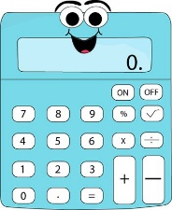

Home Link Workers – Scottish Attainment Challenge

Home Learning Activities

Activity Title: Broken Calculator Game
Age range: | 7+
Area of the Curriculum: | Literacy / Numeracy / Health & Wellbeing / STEM/ Expressive Arts
Resources required: | A calculator, piece of paper to cover certain button or paper to draw your own!
Time / length of the activity: | 5- 15mins to set up and create, 30 mins+ to play.
Number of people required: | 1+
Instructions: | Create or use counters (between 1-5) to cover numbers and functions on either a calculator you have or one you have drawn (see below for an example of an simple one to draw!). For example, you may have used 3 counters to cover the ‘1’, ‘4’ and ‘X – multiplication’ buttons.  Then give yourself a total number that you are going to try make with the numbers and function you have left.  e.g. How many way can you make the number 12 without using the numbers and functions you have covered?  If playing with others you can set totals for each other and different covered numbers and functions! If you have a physical calculator you could use this to help, but try your best to write down your solutions and try them out first!
Further learning opportunities: | Increase the difficulty by covering more numbers and functions. Add a timer if playing with others to see how many different ways you can make the same number in 60 seconds!
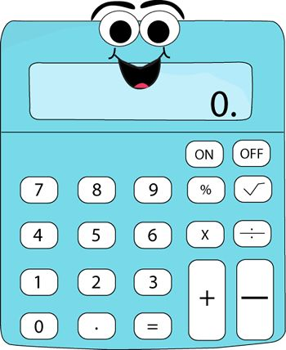
Cut your counters to cover different buttons!

