Sit less and walk more
Tags: Primary Secondary Health and Well Being (HWB) Parents Early years

What is this?
This activity provides tips and advice on how to encourage your child or young person to sit less and walk more.
Can you sit less and walk more each day?
Can you encourage your child/young person to sit less and walk more by doing the same yourself?
Walking is inclusive, safe, easy to do and fun. All you need is weather-proof clothes in Scotland!
'Walking builds bones and muscles, and helps kids grow up big and strong. It also improves stamina, reduces stress, and boosts the immune system for 24 hours.' NHS - change 4 life

Who is this for?
Parents of early years, primary and secondary school learners. This activity is aimed at young children/people from early years to S3.
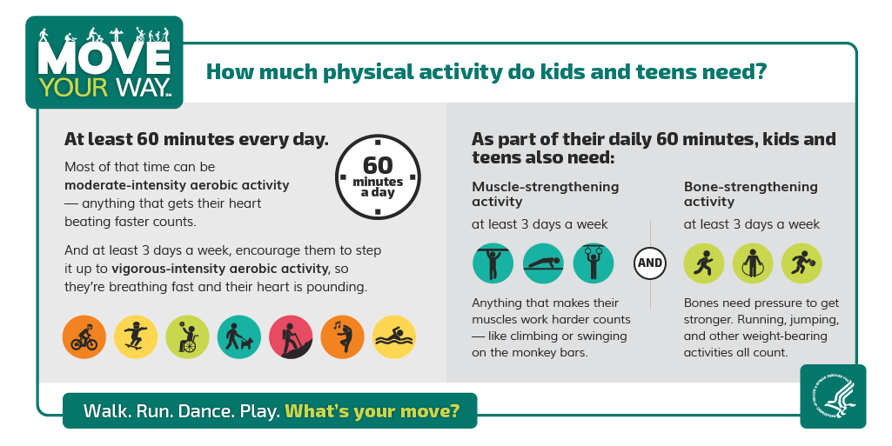

Information for parents/carers, children and young people
Tips to reduce sitting time:
- consider ways for children and teenagers to "earn" screen time
- agree a family limit to screen time per day
- make bedrooms a TV, computer/laptop and phone-free zone
- set "no screen time" rules to encourage other activities
- encourage participation in house chores such as setting the table or taking the bins out
- choose gifts such as a scooter, skateboard, ball or kite to encourage active play
Parents/carers could lead by example by also reducing their TV time and other sitting-based tasks.
NHS - Why we should sit less
NHS - Physical activity guidelines for children and young people

For children at P1
Things to do on your walk with your family:
- As you walk, can you find something green (add colours)?
- On your walk, collect some natural items, for example, twigs, stones, leaves to create a picture back home
- Can you walk with someone from your family and step at the same time together trying to keep in rhythm?
- As you walk, can you splash in puddles/see who can make the biggest splash?
- As you walk, play word games, for example, the alphabet game, counting games, i-spy, spot wild-life?
- Can you count the rainbows you can see in the windows of the houses and shops?
What changes do you notice in your body as you walk? How do you feel?

For children at P2 - P4
Things to do on your walk with your family:
- Have a treasure hunt on your walk. Can you spot these things?:
  - A feather
  - A colourful leaf
  - Something that could float
  - Something spikey
  - A bit of wood or a stone that looks like an animal
  - Something yellow
  - What else can you spot?
What changes do you notice in your body as you walk? How do you feel?
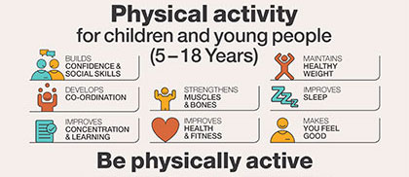

For children at P5 - P7
Things to do on your walk with your family:
- Find out about local walking routes.
- Plan a daily walk for you and your family.
- Set a target for distance and time.
- Describe why people should sit less and walk more
- Walk for 1 minute then stop. Feel your pulse in your wrist and listen to your breathing. How does your body feel during and after your walk?
BBC Bitesize - What does the heart do?
BBC Bitesize - How do humans breath?
BBC Bitesize - Taking your pulse

For young people at S1 - S3
Things to do on your walk with your family:
- Find out about local walking routes.
- Plan a daily walk for you and your family.
- Set a target for distance and time.
- Try to increase your fitness by walking and running in short bursts. Can you encourage a family member to join you in the jogging part?
- Over the weeks, you can increase the number of times you repeat jogging then walking or you can increase the length of time you jog.
- Pay attention to breathing rate and ability to talk as you walk/jog. This helps you to monitor your body’s reaction to physical activity.
- Research Scottish Government physical activity guidelines for your age group. In what ways might you meet the daily target?
Extra challenge: Couch to 5k

