Fun at home:
Activity: House of cards

You will need: playing cards

How to Play:

Carefully stacking your cards one on top of the other, build a house, a garage for your cars or a stable for you poney... See how high you can keep going without a collapse!
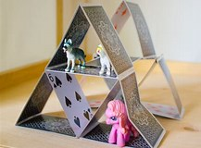

Literacy and Numeracy activities

# ScottishAttainmentChallenge
For hygiene reasons please ensure you wash your hands and any objects you have been touching after you have finished the activity.

