Create and develop a sandwich shop

Primary
Tags: Themed learning Primary Parents

What is this?
This activity is about opening a new sandwich shop.

Who is this for?
Parents of primary school learners.

For children at Primary 1 stage
Parent and child activity:
- Set up an imaginative play sandwich shop at home.
- Ask your child the kind of things that could be in the sandwich shop.
- Ask your child to gather some things together and create your shop. It can show what your child feels is in a shop and can include real items such as chairs, a table, cutlery, cups and perhaps real coins.
- Play together and take turns being the customer and shop worker. Use the money to pay for items. Food items may be real or made from objects in the house that the child thinks represent food.

For children at Primary 2 /3 /4 stages
- You are opening a new sandwich shop. Think of a name for your new sandwich shop. Design an eye-catching poster to advertise your shop.
- You want to make sure lots of people come to your sandwich shop. Make a list of all the places where you should put your poster. Remember - this should make sure as many people as possible know about your new shop.
- Ask a family member to say what they liked about your poster.

For children at Primary 5 /6 /7 stages
- You are opening a new sandwich shop. Your new sandwich shop is in a busy city which has a lot of visitors. You want to make sure you have lots of visitors to your sandwich shop.
- You decide to have a European week and plan to write the menu in different European languages.
- Choose a language you learn at school (but not English).
- Choose five ingredients you will include in your shop menu. Now create your shop menu using the European language of your choice.
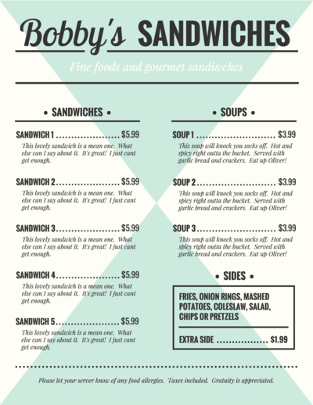
- Read your menu to your parent/carer in the language you learn at school.

For Secondary S1/2/3
- You are opening a new sandwich shop. Your new sandwich shop is in a busy city which has a lot of workers. You want to make sure you have lots of workers to your sandwich shop.
- Do a quick survey via social media to ask your family and friends or research the internet to find out what the most popular sandwich fillings and drinks are. Try to find out what people normally pay for sandwiches and drinks.
- Create your own menu that includes your sandwich creations and your drinks options. Don’t forget to add prices.
- Take a picture of your menu and share it with friends. Ask them to provide you with feedback on the items on your menu and your costings.

