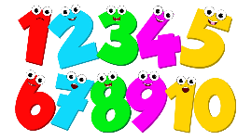
Pebble maths

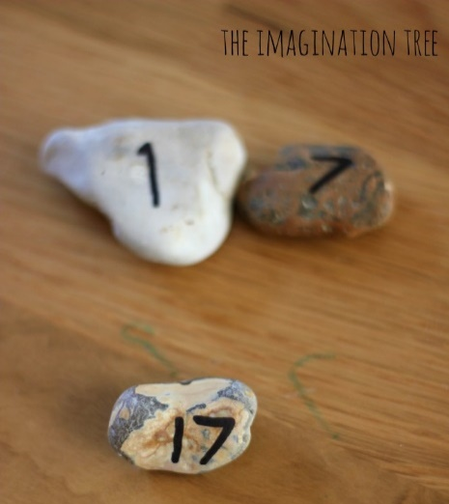
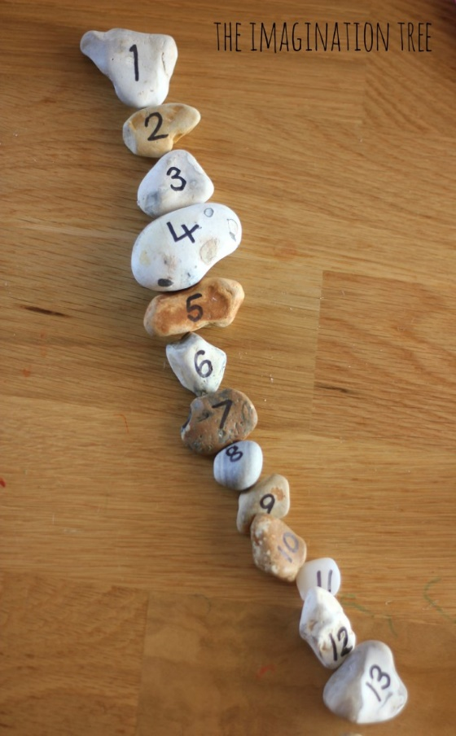
What you need:
- Pebbles
- Marker or sharpie pen

Activities
- Let’s find 5/10/20 pebbles or stones in the garden or when we are out for a walk (please wash your hands and the stones for 20 secs when you get back in the house)
- Let’s write a number on each stone. (Adult can do the writing)
- Point to a random pebble and ask ‘what is this number called?’
- Can you order the numbers from 1 – 5 or 1 -10 or 1 -20
- With the pebbles arranged in order, ask your child to close their eyes. Remove a number from the line. Open your eyes – which number is missing?
- Can you give me 2 pebbles that add together to make 5?
- With pebbles arranged in order in a line ask your child, ‘Can you tell me the number that is before 3?’ ‘before 10’ ‘before 6’ etc
- Again with pebbles arranged in order in a line, ask your child, ‘can you tell me the number that comes after 6?’ ‘after 2?’ ‘after 4?’ etc
- Which 2 pebbles do we need to make number 17? (1 and 7) etc

