[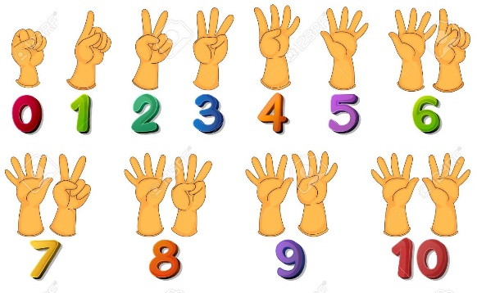](https://www.google.co.uk/url?sa=i&url=https%3A%2F%2Fwww.123rf.com%2Fphoto_32958592_stock-vector-illustration-of-a-set-of-number-zero-to-ten.html&psig=AOvVaw1jYJOz79xO3Qawq7ewh-WD&ust=1589892595312000&source=images&cd=vfe&ved=0CAIQjRxqFwoTCPjk5dG5vekCFQAAAAAdAAAAABAP)[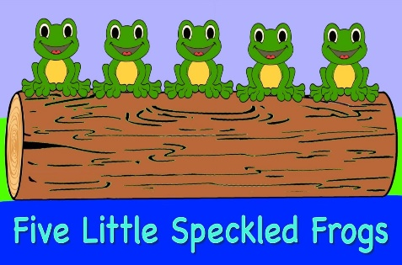](https://www.google.co.uk/url?sa=i&url=https%3A%2F%2F4570book.info%2Famazing-cliparts%2F5-green-and-speckled-frogs-clipart.htm&psig=AOvVaw0YfqwDtkm68xoDfjPMuLWT&ust=1589892745204000&source=images&cd=vfe&ved=0CAIQjRxqFwoTCIj_zpa6vekCFQAAAAAdAAAAABAD)