Early level – Useful websites/links

Cbeebies – Grow together at home
Down on the Farm - Grow together at home! Introduce your little one to gardening with these easy-to-grow indoor herbs. You don't need a whole farm, or even any outdoor space to start growing things with your child.
https://www.bbc.co.uk/cbeebies/joinin/down-on-the-farm-grow-your-own-article

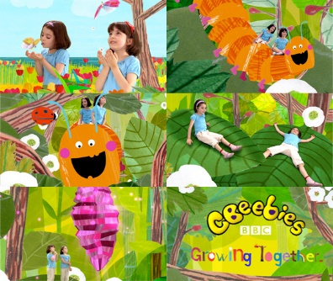

Amazing Science Can Be Really Easy

10 cool science experiments to do - most of these experiments are very easy and include household items. There is one, however, that requires buying things not found in typical homes.
https://www.youtube.com/watch?v=4MHn9Q5NtdY
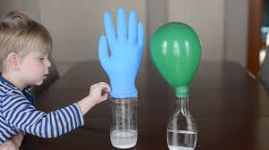

EasyPeasy: Learning through play

EasyPeasy sends game ideas to parents of pre-school children to encourage play-based learning at home. Parents receive a weekly text message directly from EasyPeasy which links to videos of example games that they can play with their child, plus tips and advice about learning through play.
Fun and games that are proven to help children's development - from birth to 5 years-old.

https://www.easypeasyapp.com/

Learn To Read Songs | Teach Your Monster To Read‎
Animated phonics songs for both revising and teaching letter-sounds. Catchy and easily adaptable, children will want to sing along and invent their own.

Lots of literacy ideas: https://www.teachyourmonstertoread.com/

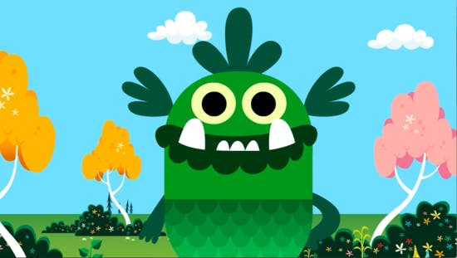

Learning to Count with these fun Counting Games - Topmarks
Children will love learning to count up to 10 with these free, fun counting games. ... Play these fun Maths Games for 3-5 year olds ...
Fun maths games for 3-5 years - https://www.topmarks.co.uk/maths-games/3-5-years/counting
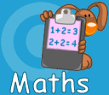

Cheer Up Rodd
BBc Bitesize – mental and emotional wellbeing class clips – Cheer up Rodd - When Rodd is ill you can cheer him up by making sure he is looking after himself, writing a new version of Humpty Dumpty and drawing him some pictures before finally turning his lights off so he can get some sleep. A new style of playful learning sketch for school or home which requires you to participate by reading the onscreen cues and doing the actions with your children.

https://www.bbc.co.uk/bitesize/clips/zdtgqp3

