Fun at home:
Activity: Fun Stuff with food

You will need:
- differents kinds of food, fruit and vegetables
- cocktail sticks

How to Play:
- Using the food stuff and your imagination, create edible cars or anything you like! The picture below will help you to get started
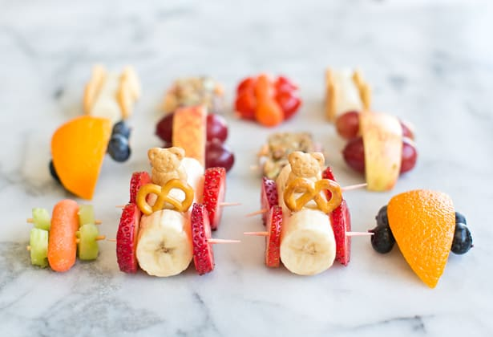

Literacy and Numeracy activities

# ScottishAttainmentChallenge
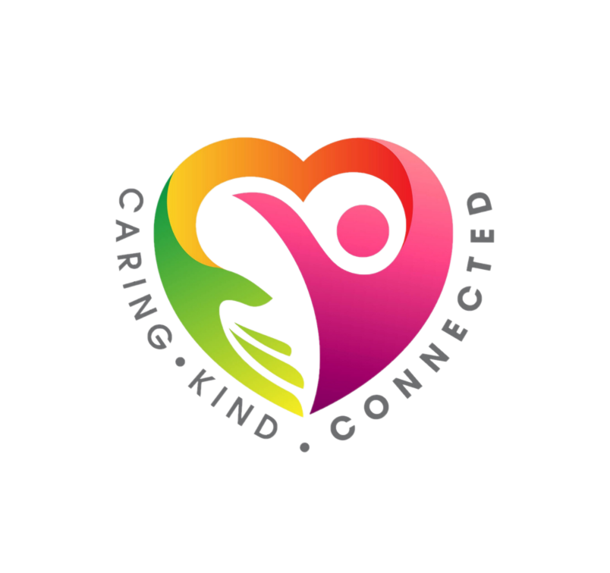
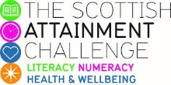
For hygiene reasons please ensure you wash your hands and any objects you have been touching after you have finished the activity.

