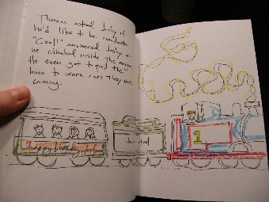

Family Literacy – Scottish Attainment Challenge

Home Learning Activities

Activity Title: | Create your story or play
Age range: | All ages
Area of the Curriculum: | Literacy
Resources required: | Anything that can be used as a prop, bags for the props.
Time / length of the activity: | None
Number of people required: | The more the better!
Instructions: | Divide the players up into groups.  Give each group a bag filled with props, such as a spoon, toy jewellery, a sock, ball or ribbon, anything you can think of.  Then give them 15 minutes to construct a story, play or sketch around the props.  The main aim of this game is to have fun and it doesn’t have to be competitive.
Further learning opportunities: | If the players want, though, they can all vote on a winning story.  Create a story book or play script of your story.
