Family Literacy – Scottish Attainment Challenge

Mentor Development Officers Activities

Activity Title: | Scavenger Hunt
Age range: | Primary 7 – S3
Area of the Curriculum: | STEM – Engineering
Resources required: | Paper, card boars, scissors, tape and any scrap resource you can find at home.
Time / length of the activity: | 1 – 1.5 Hours
Number of people required: | 1 +
Instructions: | 1. Build a structure that will hold a book 6 inches off the ground.  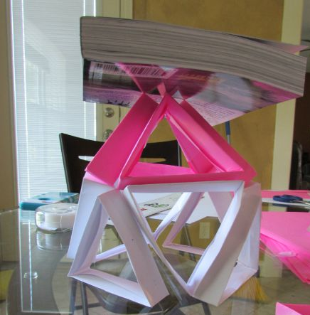  2. Build a structure that will hold and egg 2 feet off the ground.  3. Build a bridge from table to table (6 inches apart or so) that matchbox cars can cross.  4. Build the highest, free-standing structure you can build with just one sheet of 8 1/2 X 11 sheet of paper  5. Make paper airplanes and see which design flies the farthest.
Further learning | How creative can you get? Create your own Engineering challenge and tweet your ideas to @EacMentors
For hygiene reasons please ensure you wash your hands and any objects you have been touching after you have finished the activity.

