Family Literacy – Scottish Attainment Challenge

Mentor Development Officers Activities

Activity Title: | Scavenger Hunt
Age range: | Primary 6 – S3
Area of the Curriculum: | Wellbeing
Resources required: | Paper, coloured pens/pencils
Time / length of the activity: | 20 – 30 minutes
Number of people required: | 1 +
Instructions: | Draw a heart in the middle of an A4 piece of paper.  Split the heart into as many sections as you would like.  Fill each section of the heart with different things you love under the following headings:  - Things I Love  - People I love  - Activities I love  - Places I love  Tip: Keep it as colour as you would like – we recommend keeping each heading a different colour.  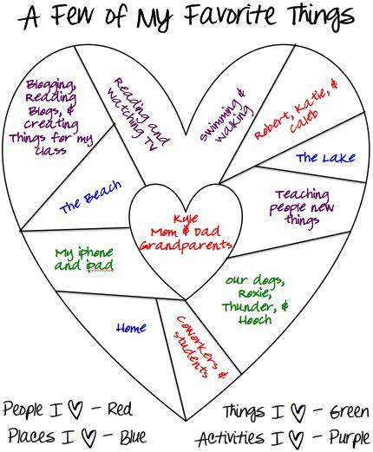
Further learning | It can be difficult to focus on the positive things when things seem so uncertain – try keeping a journal noting your thoughts and what keeps you positive.
For hygiene reasons please ensure you wash your hands and any objects you have been touching after you have finished the activity.

