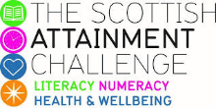

Family Literacy – Scottish Attainment Challenge

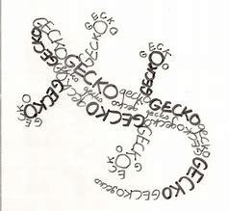
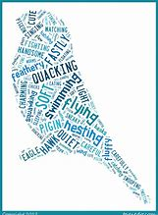
Home Learning Activities
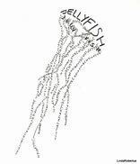

Activity Title: | CALLIGRAMS Pictures poems and stories
Age range: | 9 – 14 (P5- S3)
Area of the Curriculum: | Literacy and Expressive Arts
Resources required: | - Pen  - Paper  - Plenty of inspiration and imagination
Time / length of the activity: | No Limit!
Number of people required: | As many as you like
Instructions: | Write a short story or poem in the shape of the poem’s or story’s main theme:  If your story is about a lizard, write it in the shape of:  - a lizard or  - A jellyfish  - A bird  - A hedgehog  - A tree…  See below:-  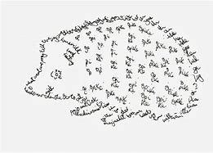
Further learning opportunities: | You could add your story / poem to Wordel and compare the results.

