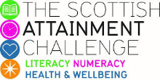
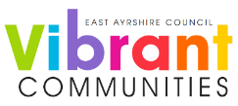

Family Literacy – Scottish Attainment Challenge

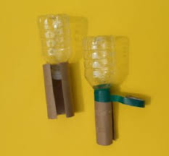
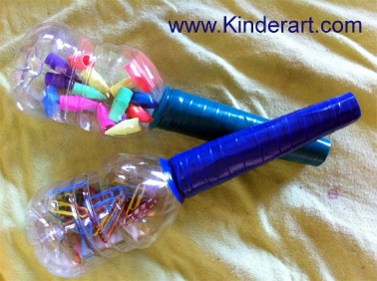
Home Learning Activities

Activity Title: | Make your own Maracas
Age range: | 4 – 11 (ECC – P7)
Area of the Curriculum: | Expressive Arts / Music
Resources required: | Small empty clean containers such as plastic bottles, screw top containers etc, rice, dry lentils or any dry pulses, paper, glue, paper, stickers, any arts and crafts resources.
Time / length of the activity: | None.
Number of people required: | As many as you like.
Instructions: | Making sure your containers are clean and dry, put a small amount of rice or pulses into each of them, secure the caps or lids, using stick tape if needed.  Using your arts and crafts resources, decorate and personalise your musical instruments.  You are now ready to experiment with your own rhythms! Play music and play along.
Further learning | Use your Maracas to make your own songs.

For hygiene reasons please ensure you wash your hands and any objects you have been touching after you have finished the activity.

