Welcome

“I wasn’t very good at school with numbers……….
I’m much better with words.”

It’s a common myth that you’re either ‘maths-minded’ or not. This just isn’t true. Everyone has the ability to be good with numbers.
You are an important partner in your child’s numeracy development.
This pack contains a variety of games that can be played by two or more people.
Playing these games will;
- develop your logical thinking skills
- help with number bonds and patterns
- encourage you and your children to play together
- improve your strategies for working out an answer
- build an understanding that there is no one ‘correct’ way of working out the answer to a number problem.
Each game comes with a set of instructions for playing it.
Maths in real life is full of creativity. With this in mind, feel free to change the rules to suit you and your opponent.
- Simplify the game for first-time players.
- Make it more challenging the more you play.
- Bend and break the rules until you have a game that is right for you.
Hopefully, as you play you’ll appreciate that far from being dull, boring and difficult, maths can be engaging, enlightening and good fun.

Always | Never
Always encourage your child to play maths puzzles. Games such as sudoku, Connect 4 and knots and crosses require logical thinking. All the games in this pack are designed to help develop maths thinking skills. | Never stop talking about numbers informally; “How many plates do we need?” “What time is bedtime?” “How many cars can you see from the window?” “How many silver ones are there?” “What if there were 6 more?”
Always encourage your child to take their time when working out an answer. Developing a strategy for getting an answer to a times table question is more valuable than learning by rote. | Never associate maths with speed. Research shows that forcing your child to work quickly on maths will develop maths anxiety and stress.
Always promote a “can-do” attitude towards maths.  “Your number work is really improving!”  “I’m really impressed with what you can do!” | Never share with your children the idea that you were bad at maths or that maths at school was boring. Research shows that as soon as this idea is shared, achievement goes down.
Always help them see where they have gone wrong. Use positive comments – “I really like how you’ve thought about that,” “That’s a good way of thinking about it,” “What else could you do with the numbers?” | Never tell your child they are wrong while they are working something out. There is always some logic to their thinking.
Never underestimate the power of the word ‘yet’ - “I can’t do this….yet.”

10 Snap
Resources: | Cards - Ace to 10 (remove the picture cards)
No of Players: | 2 – 4
Object: | Make 10 snap
Rules:
- Take the picture card out of the deck (keep the Ace as number 1).
- Deal the cards out equally between each player.
- Players must not look at their hand. Each player takes turns to place a card down.
- A snap is achieved if two cards add to make 10.
- Winner is the person with the most cards.
Things to talk about as you play:
- How many different ways can you think of to make 10?
Extension:
- Set different amounts to make snap.
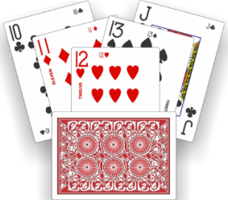

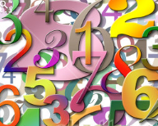

Addition Facts
Resources: | Template (Enclosed)
No of Players: | 1 or more
Object: | Addition facts
Rules:
- Using the blank templates enclosed write different numbers in the top circle.
- Now partition (break up a number to make it more usable) into the number using knowledge of addition facts.
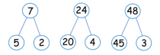

Things to talk about as you play:
- Are there other solutions? What are they? How many?

Extension:
- Increase the numbers to be partitioned

Half it
Resources: | Cutting food
No of Players: | 2
Object: | Talk about whole and fractions
Rules:
- You could use any food e.g. apples, orange, pizza cake.
- First talk about how the item is a whole before it is cut or eaten.
- Cut the item in half. Talk about how the whole has now split equally into 2 halves.
- Cut the halves. Talk about how we now have split the item halves to 4 quarters.
- Ask if you cut all the pieces again how many parts will there be of the whole?
Things to talk about as you play:
- How can we cut the whole into 3 pieces? What would we call each piece?
Extension:
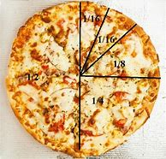
Use a picture to show the fractions
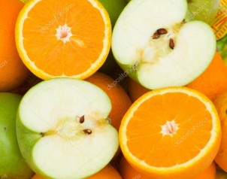

The Broken Calculator Game
Resources: | Calculator/smartphone, paper & pencil
No of Players: | Two or more
Things to think about: | Mathematicians know that there are different ways to represent a quantity – for example, 18 can be represented as 20 – 2 and as 15 + 3.
Rules:
- Ask your child to pretend that the number 8 key on the calculator is broken.
- Ask how he or she can make the number 18 appear on the screen without the 8 key. (Sample answers include 20 – 2 and 15 + 3).
Extension:
- Ask other questions of the same type by using different “broken” keys. Make this task easier or more challenging by varying the number your child must show on the calculator.
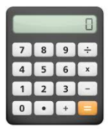

Array Hunt
Resources: | Paper and pen
No of Players: | 1-4
Object: | Arrays in real life
Rules:
- Talk about what an array is?
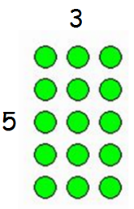
Arrays are a pictorial representation to help children understand times tables.
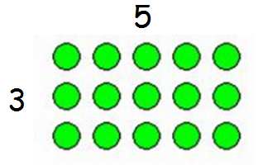

3 x 5 = 5 x 3 = 15 (total number of dots)

- Search around the house/ outside for arrays.
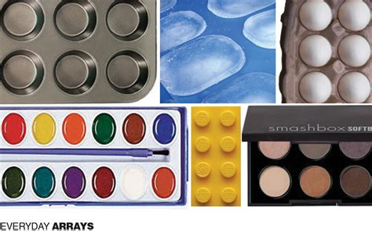
- Examples of Arrays
Things to talk about as you play:
- How can we use arrays to count?
Extension:
- Ask your child to arrange their toys in different arrays.
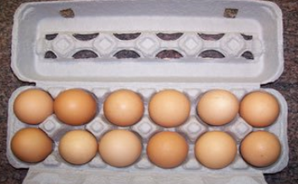

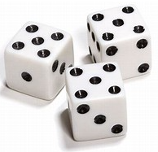

15 to Zero
Resources: | 1 die
No of Players: | 2 or more
Object: | Subtract to get to zero
Rules:
- Player 1 rolls the die & subtracts the number from 15 eg. if player 1 rolls a 3 their score is 15 – 3 = 12.
- Subsequent players do the same.
- Players continue to subtract the number rolled from their score until a player scores exactly zero.
- Note: If you have a score of 3 & roll a 4, you don’t win and must take another turn.
Things to talk about as you play:
- Is it better to go first or second? Does it matter?
- Is this a game of luck or skill?
Extension:
- Use 2 dice & start at 30.
- If a score is less than 6, set a limit of 3 more rolls.
- If no-one scores zero, the player closest wins.
- Negative numbers, 5 rolls, how low can you go?

I Spy
Resources: | Paper and pen
No of Players: | 2
Object: | Develop number awareness
Rules:
- This game could be played at home, outside and in the car.
- The first player starts by saying “I spy 6 somethings in the room…..”
- Second player looks around the room for 6 objects and makes a guess, “6 chairs?”
- Once the guess is correct change players.
- An alternative question could be “I spy something that has a number 5 on it…..”
Things to talk about as you play:
- How did you count 6?
Extension:
- The child could make pictures of the objects with the number representing it.

One Half Equals One Half –Or Does It?
Resources: | Variety of Household Objects
No of Players: | Two or more
Things to think about: | A fraction shows the relationship between a part and the whole.
Rules:
- With your child, gather several similarly shaped objects, such as a piece of paper, a towel, a placemat, a picture frame, a mirror, a magazine or a book.
- Ask your child to show you one half of each object, perhaps by using a string to mark the halfway point. This is an opportunity for your child to see that each fractional portion must be of equal size.
- Compare one half of a towel with one quarter of a blanket. Ask, “Is one half always larger than one quarter?” Use other materials to extend the conversation to a variety of situations, such as portions on different-sized plates or space in different-sized rooms.
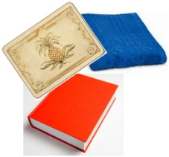

Pelmanism
Resources: | Playing cards Ace - 10
No of Players: | Two or more
Object: | To use your memory to make 10
Rules:
- Spread cards face down.
- Take it in turns to turn over pairs of cards. If they make 10, take the cards from the table.
- If your pair does not make 10, turn the cards face down again and try to remember their position.
- The winner is the person who has collected the most cards at the end of the game.
Extension:
- Change the target number.
- Turn over 3 cards each time.

Deal & Add/Subtract
Resources: | One pack of playing cards
No of Players: | One or more
Object: | To add the value of the numbers on cards dealt, highest total wins
Rules:
- Deal 2 cards.
- Add the total value of your cards.
- Decide who has the greatest/least value.
Extension:
- Deal 2 cards and find the difference between the value on each card.
- Repeat the process dealing 3, 4 or more cards.
- Find the difference between the scores of the person with the highest and lowest scores.
- Multiply the Numbers.
- Find the number 1 before/after or 10 before/after.
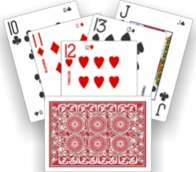

Money Game
Resources: | Money Coins
No of Players: | Two or more
Things to think about: | Try to encourage children to use a variety of coins
Rules:
- One person is the banker and the other is the accountant. You can alternate roles with your child in the game. Use amounts of money that can be shown by using coins only – for example, £0∙75.
- Banker: “I have £0∙75 in my bank. What combination of
coins might I have?”
The accountant shows one or more possible combinations.
- Banker: “I have £0∙75 in my bank. What is the smallest number of coins I could have to make this amount?” The accountant uses the fewest coins possible to show the amount.
- Banker: “I have £0∙75 in my bank. I have ten coins. What coins could they be?”
The accountant uses ten coins to show the amount.
Extension: Vary the amount of money.
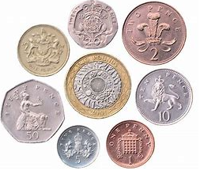

Shopping list
Resources: | Paper, pencil
No of Players: | 2-4
Object: | Write a list, quantities
Rules:
- Prepare a shopping list with the child. This could be written words or drawings of the items.
- Ask the children to think of quantities needed e.g. “How many apples do we need for each person in the house?”
- You could go out to buy these items or set up a pretend shop at home.
Things to talk about as you play:
- Talk about quantities and how sometimes each person needs 2 of something.
Extension:
- Child does a shopping list for their teddies picnic.
- Give each item a price and work out the total cost.
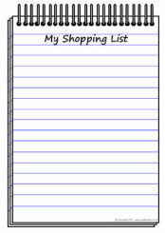

What’s My Number?
Resources: | Paper , Pencil, Number Line drawn
No of Players: | Two or more
Things to think about:
- Thinking about how a number compares or relates to another number helps us to think about numbers like mathematicians do – flexibly, that is!
- A number line is a visual tool used to compare numbers. Here’s an example of a number line showing 3∙2

Rules: | 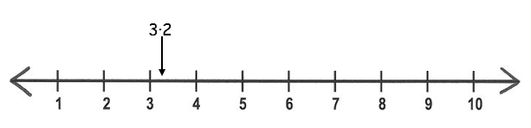
- Think of a decimal number to use in the game. For example, tell your child, “My decimal number lies somewhere on this number line. It is greater than 1 and less than 4.”
- Your child now tries to guess your number by asking questions to which you can give only a yes or a no response. For example, “Is the number between 2 and 4?” “Is the number greater than 3.5?” Continue until your child guesses the number you have picked and writes your number on the number line where it belongs.
- Reverse roles and let your child pick a decimal number and a number line and repeat the process.
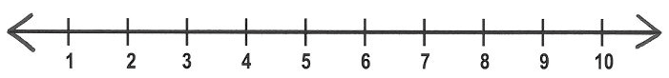

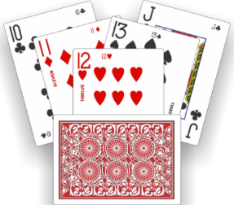

Make Twenty
Resources: | Pack of playing cards – picture cards removed
No of Players: | One or more
Object: | To add consecutive cards to make 20
Rules:
- Shuffle cards and place face down.
- Turn over one card at a time and place it face up in line.
- When you see a set of cards next to each other which total 20, remove the set and close the gap.
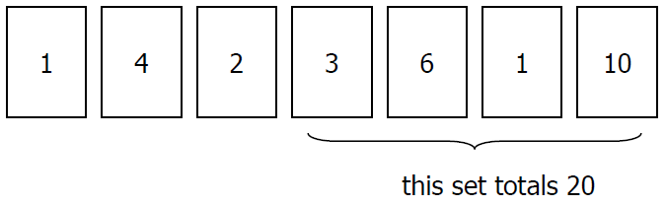
- Continue until you have removed as many cards as possible.
Extension:
- Vary the target total number.

